**AWS Logging Assignment**

1. Configure CloudWatch logs: Configure CloudWatch logs to capture logs from your AWS resources, such as EC2 instances and Lambda functions.

1. Monitor billing and cost with CloudWatch: Use CloudWatch to monitor your AWS billing and cost, and create alerts when certain thresholds are reached.

We don’t have option for billing on free tier or plural sandbox

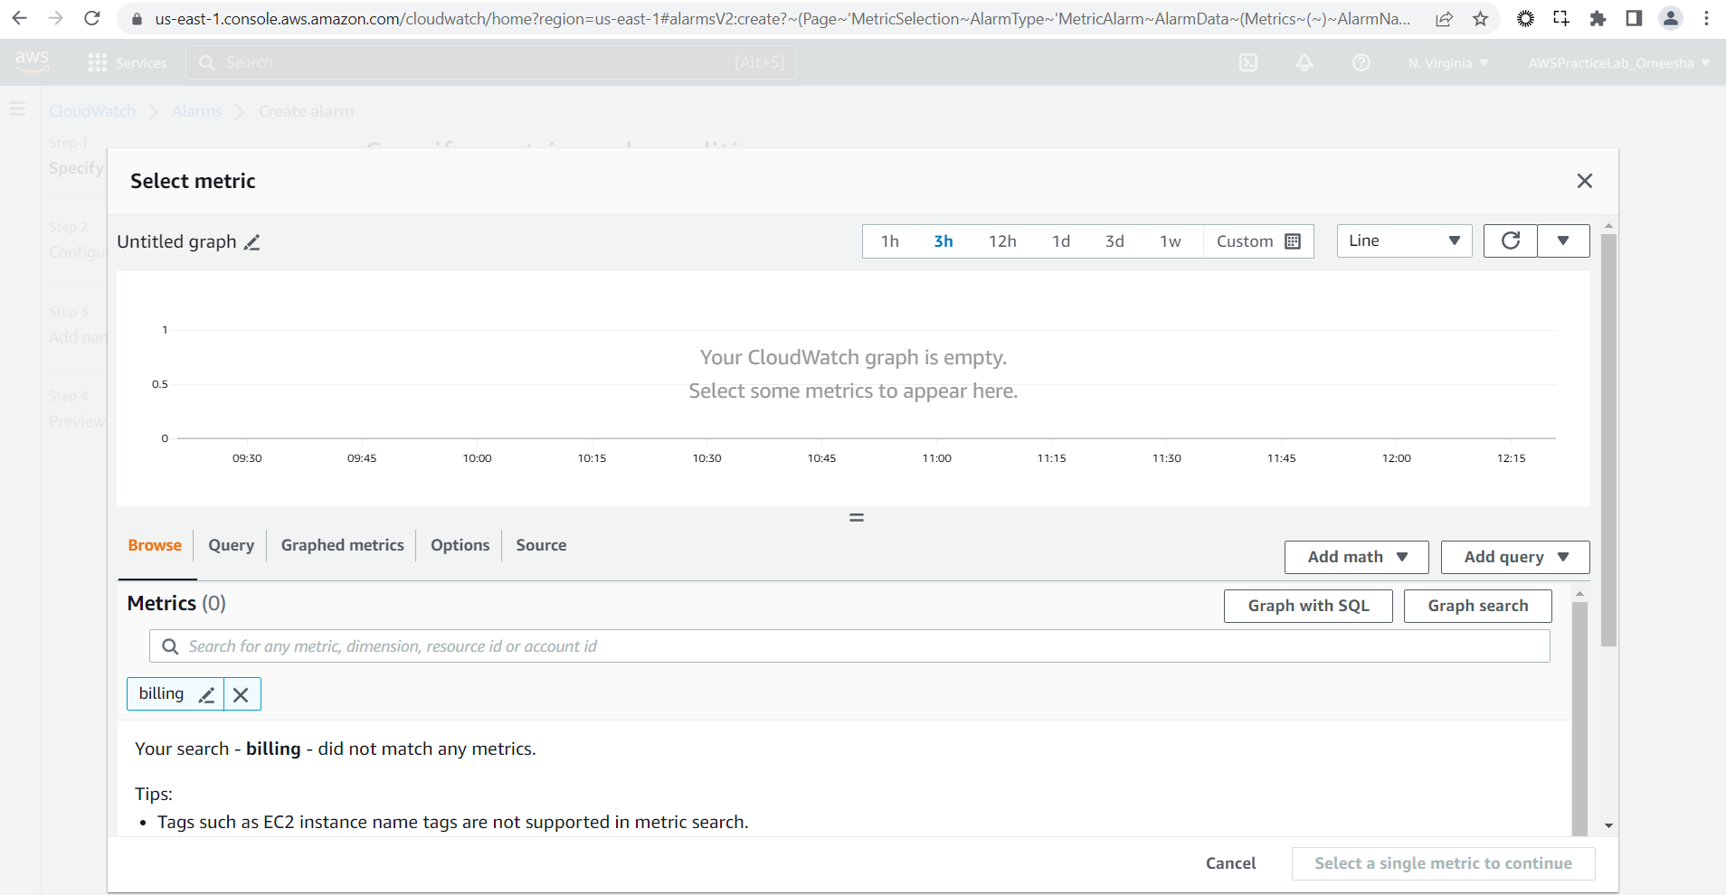

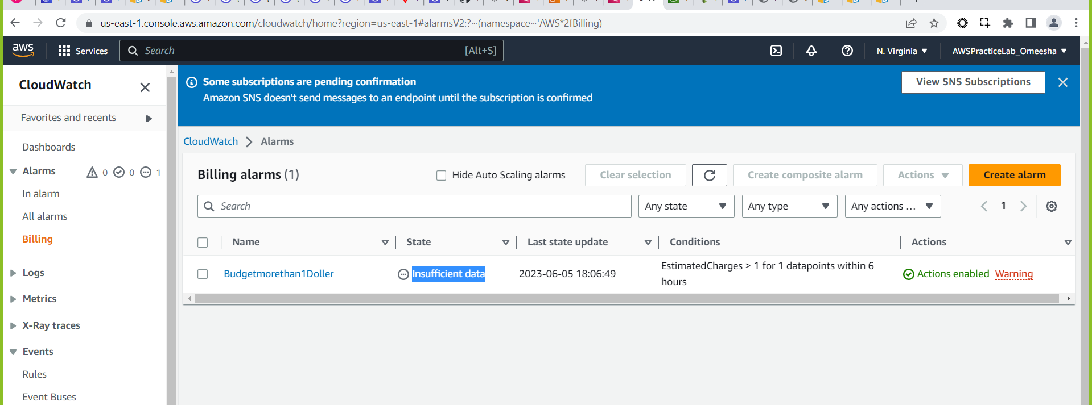

1. Create CloudWatch alarms for S3 buckets: Set up CloudWatch alarms to notify you when S3 buckets reach certain thresholds, such as when the number of objects in a bucket exceeds a certain limit or when the amount of data stored in a bucket reaches a certain size.

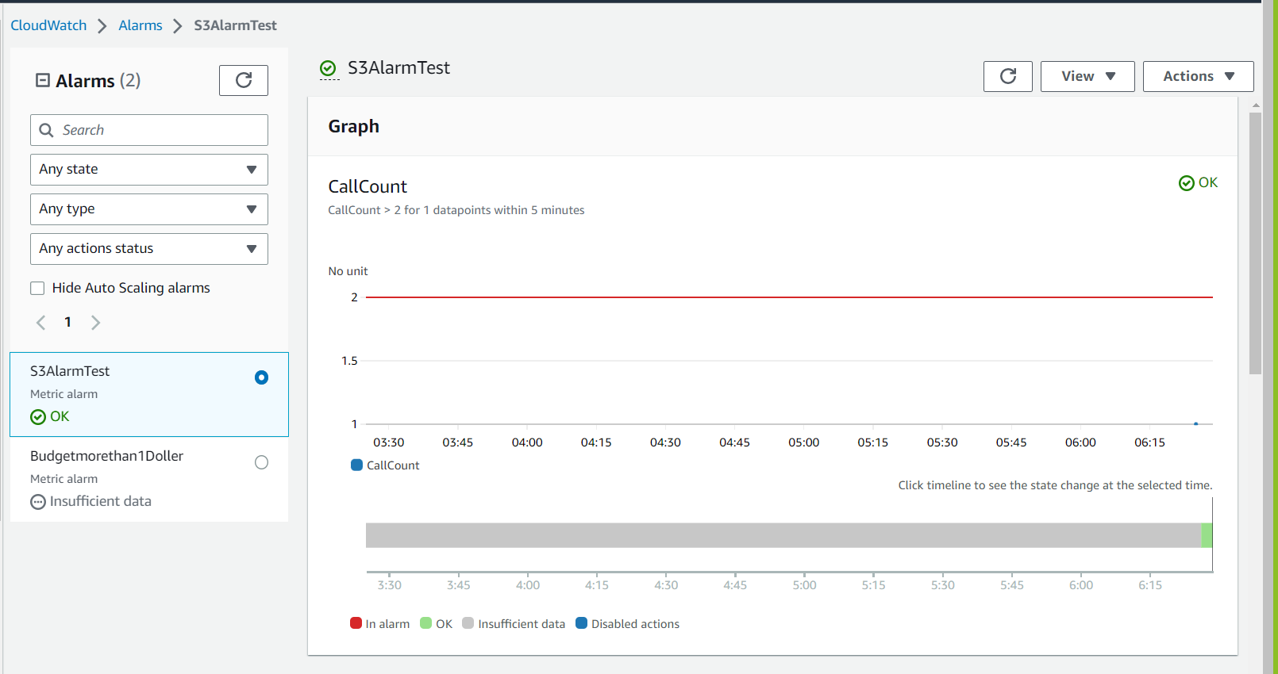

1. Use CloudWatch to monitor EC2 instances: Set up CloudWatch to monitor the performance of your EC2 instances, such as CPU utilization, memory usage, network traffic, and disk I/O.

1. Monitor Lambda function performance with CloudWatch: Use CloudWatch to monitor the performance of your Lambda functions, such as memory usage, duration, and error rates.

